# **DEPARTMENT OF COLLEGIATE AND TECHNICAL EDUCATION, BENGALURU - 560 001**

**Government Polytechnic, Bagepalli, Chikkaballapur-561207**

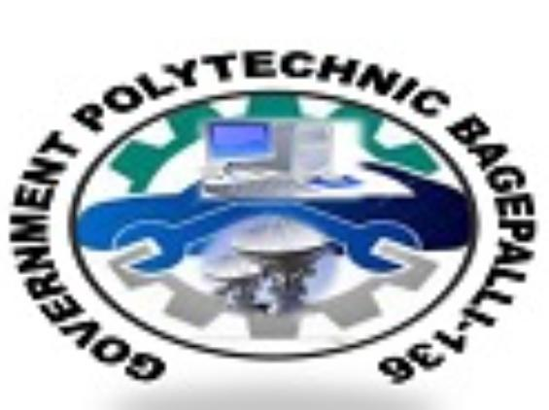

DEPARTMENT OF COMPUTER SCIENCE & ENGINEERING

Fifth Semester

Diploma in Computer Science & Engineering

CYBER SECURITY

(20CS54I)

Topic: INSTRUSION DETECTION SYSTEM



**SUBMITTED BY SUBMITTED TO**

PRAVEEN G SHWETHA MAM

136cs21040 And GAYATHRI MAM